**Practical No 05**

**X.1**

* **Program:**

<?xml version="1.0" encoding="utf-8"?>

<androidx.constraintlayout.widget.ConstraintLayout

xmlns:android="http://schemas.android.com/apk/res/android"

xmlns:app="http://schemas.android.com/apk/res-auto"

xmlns:tools="http://schemas.android.com/tools"

android:layout_width="match_parent"

android:layout_height="match_parent"

tools:context=".MainActivity">

<LinearLayout

android:layout_width="409dp"

android:layout_height="729dp"

android:orientation="vertical"

tools:layout_editor_absoluteX="1dp"

tools:layout_editor_absoluteY="1dp">

<TextView

android:id="@+id/textView3"

android:layout_width="match_parent"

android:layout_height="wrap_content"

android:text="Place Name"

android:textSize="24sp"/>

<EditText

android:id="@+id/editTextTextPersonName"

android:layout_width="wrap_content"

android:layout_height="wrap_content"

android:ems="10"

android:inputType="textPersonName"

android:textSize="24sp" />

<TextView

android:id="@+id/textView2"

android:layout_width="match_parent"

android:layout_height="wrap_content"

android:text="Age"

android:textSize="24sp"/>

<EditText

android:id="@+id/editTextNumber"

android:layout_width="wrap_content"

android:layout_height="wrap_content"

android:ems="10"

android:inputType="number" />

<TextView

android:id="@+id/textView"

android:layout_width="match_parent"

android:layout_height="wrap_content"

android:text="Mobile No"

android:textSize="24sp"/>

<EditText

android:id="@+id/editTextNumbr2"

android:layout_width="wrap_content"

android:layout_height="wrap_content"

android:ems="10"

android:inputType="number"/>

</LinearLayout>

</androidx.constraintlayout.widget.ConstraintLayout>

* **Output:**

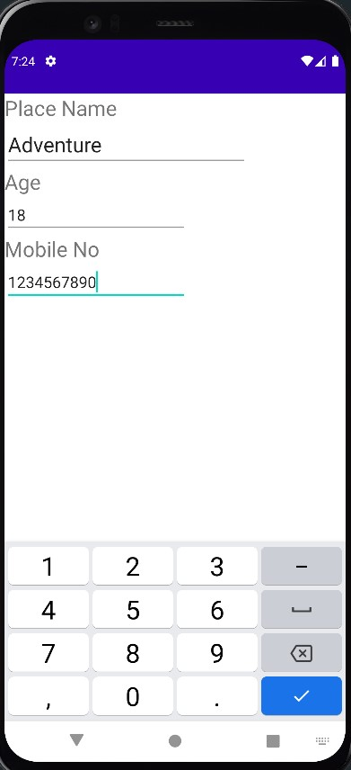

# **X.2**

# **Program:**

<?xml version="1.0" encoding="utf-8"?>

<androidx.constraintlayout.widget.ConstraintLayout

xmlns:android="http://schemas.android.com/apk/res/android"

xmlns:app="http://schemas.android.com/apk/res-auto"

xmlns:tools="http://schemas.android.com/tools"

android:layout_width="match_parent"

android:layout_height="match_parent"

tools:context=".MainActivity" >

<AbsoluteLayout

android:layout_width="409dp"

android:layout_height="729dp"

android:orientation="vertical"

tools:layout_absoluteX="33dp"

tools:layout_absoluteY="1dp" >

<TextView

android:id="@+id/textView"

android:layout_width="wrap_content"

android:layout_height="wrap_content"

android:layout_x="125dp"

android:layout_y="215dp"

android:text="Place Name"

android:textSize="24dp"/>

<TextView

android:id="@+id/textView2"

android:layout_width="52dp"

android:layout_height="wrap_content"

android:layout_x="169dp"

android:layout_y="286dp"

android:text="age"

android:textSize="24sp" />

<TextView

android:id="@+id/textView3"

android:layout_width="wrap_content"

android:layout_height="wrap_content"

android:layout_x="132dp"

android:layout_y="380dp"

android:text="Mobile No"

android:textSize="24sp" />

<EditText

android:id="@+id/editTextTextPersonName2"

android:layout_width="wrap_content"

android:layout_height="wrap_content"

android:layout_x="85dp"

android:layout_y="237dp"

android:ems="10"

android:inputType="textPersonName" />

<EditText

android:id="@+id/editTextNumber"

android:layout_width="wrap_content"

android:layout_height="wrap_content"

android:layout_x="86dp"

android:layout_y="322dp"

android:ems="10"

android:inputType="number" />

<EditText

android:id="@+id/editTextNumber2"

android:layout_width="wrap_content"

android:layout_height="wrap_content"

android:layout_x="86dp"

android:layout_y="411dp"

android:ems="10"

android:inputType="number" />

</AbsoluteLayout>

</androidx.constraintlayout.widget.ConstraintLayout>

* **Output:**

# 